_VOIS Documentation



Data Preparation

⦁Customers IDs are changed to be numeric instead of strings for both space saving and performance reasons.

⦁A derived column from Date of Birth is added "Age" and depending on it, a conditional column with Customer Age Segments is added.

⦁The Segments started from age 20 as our youngest Customer is at the age of 26 so there was no need for more Segments for now, only Adults, Middle-aged and Senior Adults.

⦁Income Segments is made using MIN, MAX, MEAN, 1ST & 3RD Quartiles.

⦁Constraints/Restrictions should be added to Customers Marital Status to have accurate data that can be considered in our marketing campaigns as the data is ambiguous.

⦁All purchases and Revenue columns are set to be currency instead of whole numbers.

⦁Measures Table is used to gather all DAX measures together for clarity.

Charts Conclusion

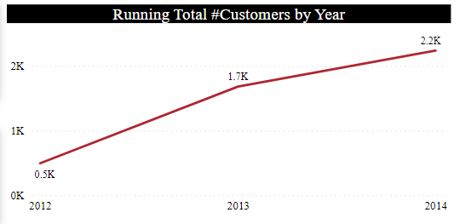

By 2013 there was a yearly increase by 1.2K customers and by 2014 the rate was decreased to 0.5K new customers.

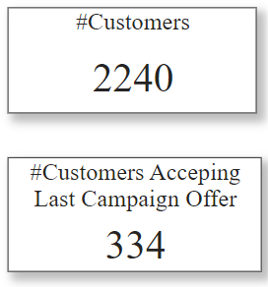

About 14.9% of our current customers accepted the last campaign offer.

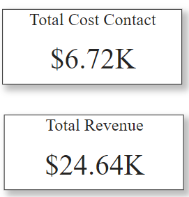

A Net Profit of 17.92K is achieved by campaigns.

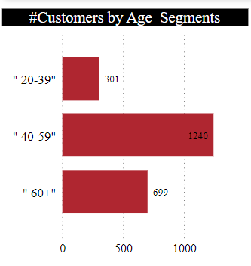

Middel-aged customers is the most common layer in our customer segments, it represents 55.36% from our customers followed by Senior Adults with 31.21% and last comes Adults with only 13.44%.

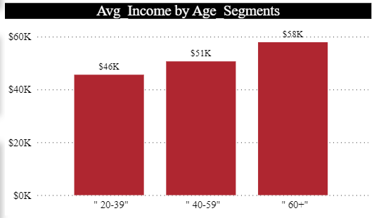

The Average income for each age segments shows that there isn't much variance for the analysis to rely on.

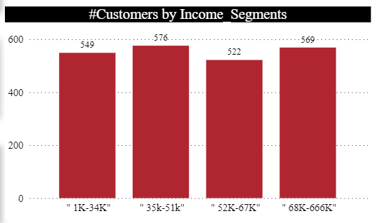

The number of customers in each income segment is closely equivalent.

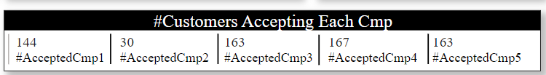

Campaign 2 was the least effective with customers while campaign 4 achieved the highest score.

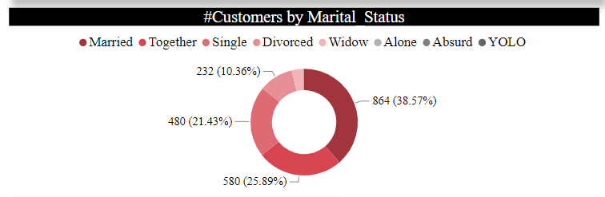

64.46% of customers have a partner therefore this information can be used in new campaigns to target them yet it's better to put restrictions to limit Marital status categories.

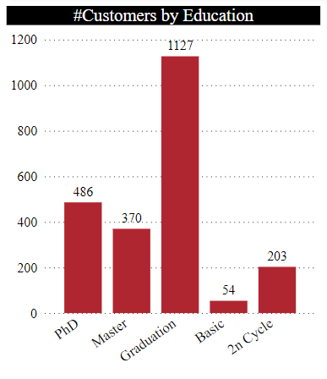

Graduated Customers hit the highest score followed by PHD. Graduated Customers represent 50.31% from the total.

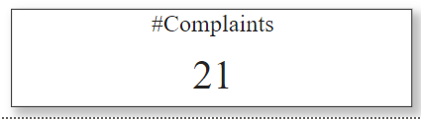

There are only 21 complaints 17 of them (80.9%) comes from Senior Adults & Middle-aged customers.

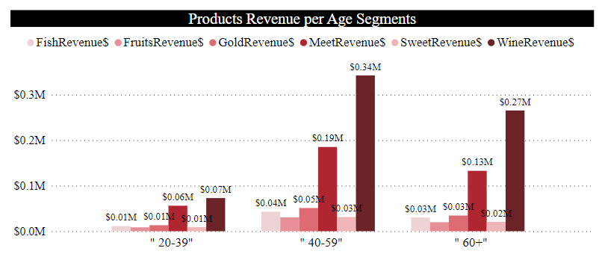

Wine and Meet are the most bought products by all customer segments so there can be offers associating them together.

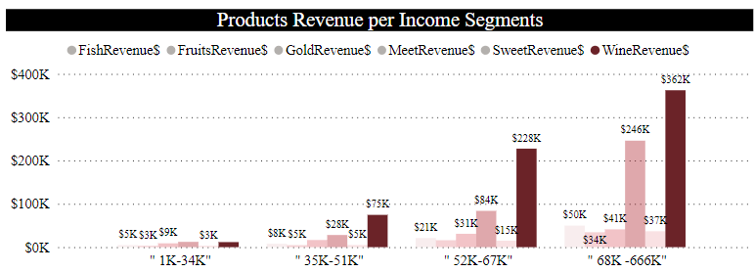

The higher the income the more customers buy our products therefore targeting customers with income > 52K should be considered.

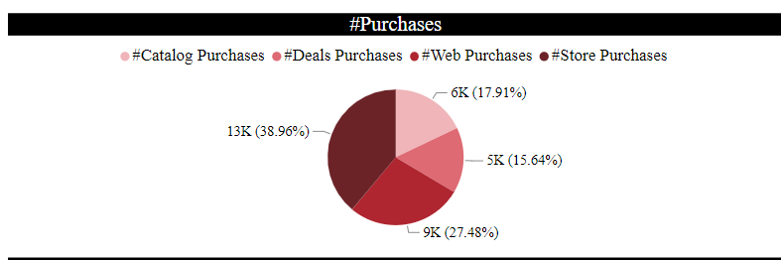

Store & web purchases are the most common types representing 66.44% of the total purchases.

Also 75% of people visiting our website do web purchases (9K out of 12K).

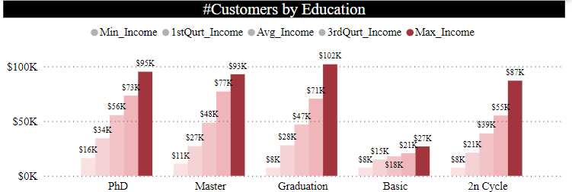

For the Adults group, different educational levels have almost equivalent income.

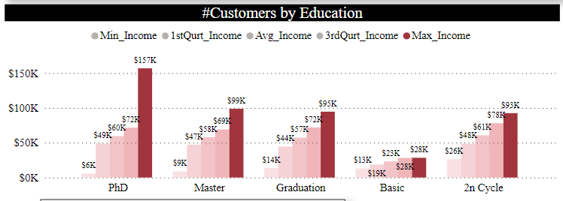

For Senior Adults, people with PhD have the highest income.

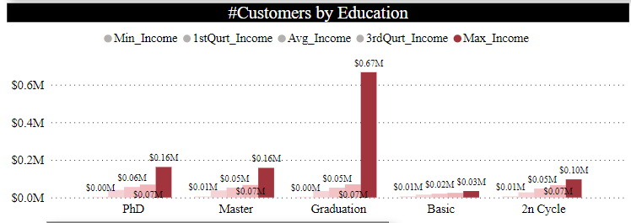

For an overall view and middle-aged segment, graduation educational level has the highest income.

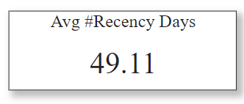

For all segments there's an average number of almost 50 days since their last purchase.

# Target Audience

It's meant for the marketing team to help them understand our customers with a better vision to guide them for better solutions to gain customers' interest and keep their loyalty to our services.

⦁Stores score the highest purchases & there's a big number of Kids and Teens in our customers' household, therefore including few activities or games to attract kids and teens to come more often should be included. Games & Toys for kids and group competitions or activities for teens.

⦁Most of our customers are married or having a partner therefore to increase the number of purchases by deals couples offers can be used.

⦁Website Ads should be spread to increase the recency as their outcome is good, 75% of website visitors make a purchase.

⦁Wine and meet are the most purchased products. They can be put close to each other in our stores or they can have offers/discounts together to raise their revenue.

⦁88.53% of our customers are well educated therefore TV Ads should be made to tickle their minds or different Ads can be done depending on different specializations.

⦁Areas of interest should be classy to target customers with high income by different marketing methods.

⦁To increase gold products revenue, when making couples offers, discounts should be considered on gold or TV Ads for couples including gold gifts when using a service.

⦁To increase sweet products revenue, customers with kids should be targeted. A questionnaire can made to know which purchasing method they use the most.